**Estimating regional trajectories and trends of seabirds from sparse and inconsistent colony counts: Case studies from eastern Canada with Leach’s storm-petrel and Atlantic puffin** – updated first draft May2024 – second draft July2024 – revised draft Aug/Sep 2024 -

*(Dave Iles, Sarah Gutowsky, Sabina Wilhelm, JF Rail, April Hedd, Anna Calvert, Greg Robertson, Heather Major – order tbd!)*

*Target Journal – ACE-ECO*

# ABSTRACT

*(make sure to include an emphasis on some of the method’s limitations, as per our chat Sept9)*

# INTRODUCTION

Despite their presence in huge numbers on coasts and islands across the world, seabird populations present numerous obstacles to population monitoring. Seabird colonies are often large, diffuse, geographically isolated, and in some cases include a very large presence of non-breeding individuals that confound estimates of breeding totals (Mercker et al. 2021). Many seabird species also nest in burrows under soil or rock, such that variable substrate, topography and detectability of breeders further complicates population censusing, whereby the method employed varies among and even within colonies (e.g. Buxton et al. 2015, Arneill et al. 2019, Lavers et al. 2019). Seabird population monitoring has thus often been conducted sporadically and with inconsistent methods, such that combining these disparate and imprecise estimates of colony size to rigorously assess population status, trajectories, and trends (i.e. annual relative abundance, patterns of change in abundance, and rates of change in abundance, respectively) of colonial seabirds at regional scales is even more of a challenge.

Adding urgency to these estimation difficulties, numerous colonial seabird populations are documented or suspected to be in decline and at risk from anthropogenic threats and ongoing environmental changes (e.g. Paleczny et al. 2015, Dias et al. 2019). In addition to long-term fisheries bycatch impacts (e.g. Anderson et al. 2011, Regular et al. 2013, Grémillet et al. 2018, Christensen-Dalsgaard et al. 2019), seabirds are now increasingly vulnerable to effects of offshore energy production, light attraction, pollution, and invasive species (e.g. Ronconi et al. 2015, Dias et al. 2019, Gilmour et al. 2023). Climate change represents a further pervasive challenge for seabirds in both their marine and terrestrial habitats (e.g. Sandvik et al. 2012, Dias et al. 2019), such that cumulative stressors can be particularly strong among widespread species (Lieske et al. 2020, Phillips et al. 2023). These myriad stressors can have localized or broad impacts depending on the spatiotemporal overlap in threats among colonies and can thus manifest as synchronous or asynchronous patterns in population change at the colony level, in turn determining long-term patterns of change at the regional level. Despite the pressing need for robust evaluation of population trajectories and trends, and ultimately drivers of change, statistical tools are not yet widely available that can account for the sparseness and uncertainty inherent in most seabird monitoring data.

Building from models described by Smith & Edwards (2021) for applications to landbird survey data, we propose a Bayesian hierarchical generalized additive mixed model (GAMM) approach for estimating regional trajectories and trends of seabird populations. This approach can handle the challenges of infrequent and imprecise colony surveys, permits flexible population trajectories without assumptions of the pattern of change over time, and allows information sharing on population change across monitored colonies while perpetuating uncertainty through the model via Bayesian methods. Because seabird surveys often use approaches that allow for estimation of total colony size, colony impacts on the regional trajectory are naturally weighted relative to colony size, allowing larger colonies to have a stronger impact on the estimated regional population dynamics. Interval-specific rates of mean annual population change, or regional trends, can then be derived from any stretch of the regional trajectory time series, with the length dictated by the required application. For example, Canada’s national species status assessments by the Committee on the Status of Endangered Wildlife in Canada (COSEWIC), as well as the status criteria for the International Union on the Conservation of Nature (IUCN), are based on trends over three generations, while more short-term trends or changes in trend over time can be more useful for assessing species recovery or extinction risk.

To demonstrate our approach and to illustrate how the results can be reported and interpreted for conservation-based uses, we apply the model to colony census data from two priority burrow-nesting species in eastern Canada, Leach’s storm-petrel (*Hydrobates leucorhous*, hereafter ‘storm-petrel’) and Atlantic puffin (*Fratercula arctica*, hereafter ‘puffin’), both of which pose challenges to population monitoring. Storm-petrels are small-bodied ‘tube-noses’ that nest in small and often concealed burrows. They have a broad distribution across the Northern hemisphere, including 100+ breeding colonies across eastern Canada ranging in size from a few individuals to several million (COSEWIC 2020; Figure 1). They are exposed to many threats to their persistence (Lieske et al. 2020, Pollet et al. 2023), showing a population decline of over 50% since the 1970s (COSEWIC 2020, d’Entremont et al. 2020, Wilhelm et al. 2015, 2020, Bond et al. 2023) that led to their designation in 2020 as *Threatened* by COSEWIC. Puffins have a similarly diffuse breeding distribution of 100+ colonies across the coasts of eastern Canada, also ranging in size from a few to hundreds of thousands of individuals (Figure 1) and can often be found on the same islands as those occupied by storm-petrels (Nettleship 1980, Wilhelm et al. 2015). In contrast to many other regions across their breeding range such as in Europe where the puffin has been listed as *Endangered* on The IUCN Red List of Threatened Species (BirdLife International 2021), the Canadian puffin population has seemingly grown in recent decades (Lowther et al. 2020), possibly linked to the closure of gill-net fisheries in the region (Regular et al. 2013). It follows that these two species in eastern Canada provide ideal case studies to demonstrate how our GAMM-based approach can be informed by time series of colony census data of varying precision and frequency across space and time to generate robust and transparent regional trajectories and trends with readily interpretable estimates of uncertainty.

Here we demonstrate the utility of a Bayesian hierarchical GAMM-based approach for estimating seabird population trajectories and trends by (i) validating the approach through simulations of realistic colony monitoring data for sporadically-censused burrow-nesting species, and subsequently (ii) applying the method to generate regional trajectory and trend estimates and interpret results for Leach’s storm-petrel and Atlantic puffin in eastern Canada. In the context of ongoing environmental change and increasing pressures on seabirds in the North Atlantic and oceanwide, this is a timely exercise for these case study species and for demonstrating the power of Bayesian methods for optimizing hard-won but limited data to meet pressing seabird conservation needs.

# METHODS

## Case study species and census methods

Puffins and storm-petrels in eastern Canada share widespread and overlapping breeding distributions (Figure 1) and burrow-nesting habits. Both species also raise a single chick which fledges at night close to adult size and is independent of parents after leaving the burrow (Lowther et al. 2020, Pollet et al. 2021). But these two species also show other contrasting life-history traits. For example, at the colony, storm-petrels are nocturnally active, while adult puffins are strictly diurnal. Puffins incubate for ~40 days, and storm-petrels for ~42 days, but they have contrasting chick-rearing strategies. Puffins forage locally to feed their chicks small forage fish several times a day over ~40 days (Harris and Wanless 2011, Pratte et al. 2017, Delord et al. 2020, Symons and Diamond 2022), while storm-petrels travel for several days and over many hundreds of kilometers to feed on deep water mesopelagic lanternfish (Myctophidae; Hedd et al. 2009), and raise their chicks for ~65 days (Hedd et al. 2018, d’Entremont et al. 2020, Collins et al. 2022). While young from both species spend the first few years of life at sea, puffins exhibit higher natal philopatry (reviewed in Kersten et al. 2021) compared to storm-petrels, which show high natal dispersal and can recruit in any colony across the North Atlantic (Bicknell et al. 2012, 2013). Storm-petrel adults are also slightly longer-lived, with a generation time of 14.8 years compared to puffins at 11 years (Bird et al. 2020). Such contrasting strategies could ultimately influence population trends in different ways even if both species are nesting in the same geographic area.

A total of 22 puffin and 12 storm-petrel colonies were surveyed at least twice between 1965 and 2023 in eastern Canada (Figure 1). In Newfoundland, puffins and storm-petrels can nest on the same island but rarely overlap in habitat type, showing distinct habitat preferences (e.g., storm-petrels prefer forested or fern habitat while puffins prefer grassy sloped habitat; Wilhelm et al. 2015, 2020, Bond et al. 2023). Elsewhere in Atlantic Canada, puffins and storm-petrel colonies do not overlap. Thus, the survey approach for both species is the same, but depending on the size of the colony, methods can vary as follows.

#### Complete hole count

The approach to count all potential burrow entrances (or holes, defined as a hole in the ground that appears to a standing observer to lead to a burrow) is the preferred method for sites where the entire island can be searched. This approach was used for smaller colonies in Newfoundland and Labrador (usually < 3000 pairs) as well as Machias Seal Island in New Brunswick since 2000, with methods previously published in Robertson and Elliot (2002a,b), Robertson et al. (2002a) and Diamond (2021). Briefly, an island-wide systematic hole count is done using a transect approach and having multiple observers walk next to each other 1-2 meters apart and count all holes encountered, or in the case of Machias Seal Island, counting all holes along transects within 4-m quadrats. For smaller islands with fewer than 200 holes (e.g., Bacalhao and Tinker Islands) all holes were assessed by inserting an arm (and using a wooden spoon to extend the reach if necessary) and assigning the hole as either being: 1) an extra entrance to a burrow, 2) too short to be a burrow (< 30 cm), 3) an empty burrow, 4) an occupied burrow with either an adult and/or egg and/or chick, or 5) unknown (i.e., the observer could not reach the end of the burrow to confirm it being occupied or not). If an island in Newfoundland and Labrador had more than 200 holes, hole assessments were done using a plot approach by laying a rope grid (either 3 X 3 m or 5 X 5 m) in areas occupied by the species (puffin or storm-petrel) and representative of the island. Each hole in the plot was assessed as described above. Depending on the island’s size, a range of 5-20 plots were randomly placed in different areas of the island at both the periphery and center of the colony. Hole occupancy rates were calculated as the number of occupied burrows divided by the total number of holes counted. Each plot was weighted by the number of holes assessed to calculate island-wide occupancy rates. Standard errors were based on the number of plots assessed on each island.

All monitored puffin colonies in Quebec are found within the North Shore Migratory Bird Sanctuaries, and survey counts were summed across six consistently monitored sites (shown in Figure 1B as a single central location representative of all colonies). For these colonies, complete hole counts have been largely phased out to minimize disturbance and replaced by counts of adults attending the colony (on land and water). Burrow counts continue at the Betchouane Migratory Bird Sanctuary, while a system of transects and quadrats is used to estimate area of occupancy and mean occupied burrow density at the Baie de Brador Migratory Bird Sanctuary (Rail 2021, Rail and Chapdelaine 2002). Storm-petrel colonies in Quebec generally consist of a few scattered pairs, with burrows often hidden in dense vegetation. In those conditions, hole counts are not efficient. Instead, the most recent petrel censuses have used playback at night and ARUs (automated recording units) to confirm the presence of the species, but do not provide reliable estimates of colony size , thus no Quebec petrel colonies were used in trend analyses.

#### Grid or transect approach

For larger colonies where complete hole counts are not feasible, island-wide grids or transect lines were set 25-100 m apart to determine the area occupied by puffins or storm-petrels, and 20-80 plots were assessed to calculate occupied burrow density as described above (see also Robertson and Elliot 2002a, Robertson et al. 2002b, Pollet and Shutler 2018). This approach is suitable for islands where puffins and storm-petrels are nesting in relatively flat areas and thus where correcting for slope is not a concern.

#### Habitat delineation

An alternative for the grid or transect approach to estimate occupied area, the use of a Geographic Information System (GIS) approach has proven to increase the efficiency of surveys and provides more accurate estimated sloped areas occupied by puffins and storm-petrels which can then be applied to the estimated occupied burrow density assessed through plots as described in the other two approaches (e.g., Wilhelm et al. 2015, 2020, d’Entremont et al. 2020, Bond et al. 2023). Briefly, estimating the area of habitat occupied by puffins or storm-petrels was done using a hand-held GPS and walking around the boundary of the nesting area and/or using high resolution imagery to delineate the various habitat types utilized by each species. On large and convoluted colonies where puffins and storm-petrels nest on slopes, maps of contour lines were also incorporated into the GIS approach to provide more accurate estimated areas on slopes (e.g., Wilhelm et al. 2015, 2020, Bond et al. 2023).

## Description of Bayesian Hierarchical GAMM

We estimated colony- and regional-level population trajectories using hierarchical state-space models. These models decompose spatio-temporal variation in seabird counts into contributions from biological processes of interest (i.e., temporal changes in colony-level population indices) and observation processes (i.e., variation due to imprecision in survey counts).

The model assumes survey counts ($Y_{i,t}$) arise from an over-dispersed Poisson process with mean $λ_{i,t}$ for colony $i$ in year $t$:

|  |  |
| --- | --- |
| $$Y_{i,t}\sim Poisson\left(λ_{i,t}\right).$$ | (1) |

$λ_{i,t}$ is a normally distributed random variable with mean equal to an expected count ($E_{i,t}$) and a variance term ($ε_{i,t}^{2}$) that characterizes the magnitude of sampling error during a survey:

|  |  |
| --- | --- |
| $$λ_{i,t}\sim Normal\left(E_{i,t},ε_{i,t}^{2}\right).$$ | (2) |

This explicitly recognizes that there are inevitable discrepancies between the numbers of birds estimated from surveys and the total number of birds that would be counted with a true colony census (i.e., $ε_{i,t}$ is the standard error associated with a survey).

The model decomposes expected counts $E_{i,t}$ into contributions from two terms through a logarithmic link function:

|  |  |
| --- | --- |
| $$\log\left(E_{i,t}\right)= µ_{i,t}+ δ_{i,t},$$ | (3) |

where $µ_{i,t}$ represents the general shape of each colony’s trajectory across years, and $δ_{i,t}$ represents annual departures of population indices from the colony-level smooths (sometimes called “process variance”).

The primary goal of our analysis is to describe temporal patterns in $µ_{i,t}$ and its variation among colonies. We accomplished this using hierarchical GAMMs that fit smoothed temporal trajectories to each colony, using an approach described in Smith and Edwards (2021) where:

|  |  |
| --- | --- |
| $$µ_{i,t}=β_{0, i}+\sum_{k=1}^{K}{β_{i,k}X_{t,k}}.$$ | (4) |

The term $µ_{i,t}$ therefore includes effects of colony-level intercepts ($β_{0, i}$) and a semi-parametric “smoothed” temporal process defined by a generalized additive function ($\sum_{k=1}^{K}{β_{i,k}X_{t,k}}$), involving the product of a series of colony-level smoothing coefficients ($β_{i,k}$) and a design matrix ($X_{t,k}$) that is constructed from a series of $K$ basis functions multiplied by a smoothness penalty. Details related to constructing $X_{t,k}$ are described in Appendix XX.

Following Smith and Edwards (2021), we estimated the smoothing parameters $β_{i,k}$ as random effects arising from a shared distribution across colonies where $β_{i,k}\sim Normal(\overline{B_{k}},σ_{B}^{2})$,. This allows the shape of colony-level trajectories to be partially conserved among colonies, if supported by the data, which can improve model predictions for colonies with sparse data. This is also a valuable feature if large-scale environmental processes (e.g., climate oscillations) affect an entire regional population in a similar way, leading to trajectories with similar shapes.

We modeled annual deviations $δ_{i,t}$ as:

|  |  |
| --- | --- |
| $$δ_{i,t} \sim Normal(0,σ_{δ}^{2}).$$ | (5) |

These deviations can be driven by a wide variety of population processes, including random annual variation in breeding propensity or environmental effects affecting recruitment. While $δ_{i,t}$ describes genuine year-to-year fluctuations in colony abundance around its temporal smooth, we focus inference for status and trend assessment on changes in $µ_{i,t}$, which represents longer-term and more persistent changes in the expected annual abundance at colonies.

Finally, our analysis included an additional sub-model to estimate the magnitude of sampling variation for cases where estimates of $ε_{i,t}^{2}$ were missing (i.e., where raw plot-level data to calculate this quantity were unavailable). For plot-based surveys of burrow-nesting seabirds, $ε_{i,t}^{2}$ can be calculated via design-based estimators of spatial population totals (Horvitz and Thompson 1952). In this dataset, there was a robust positive empirical relationship between $\log\left(ε_{i,t}\right)$ and ${log(Y}_{i,t})$, based on surveys that had both quantities available (Figure SXX). We therefore estimated missing values of $ε_{i,t}$ by nesting an additional linear regression within our Bayesian model:

|  |  |
| --- | --- |
| $$\log\left(ε_{i,t}\right)\sim {Normal(ξ}_{0}+ξ_{1}{log(Y}_{i,t}),σ_{ε}^{2}).$$ | (6) |

## Estimation of Population Indices, Trajectories and Trends

For each colony, we calculated estimates of relative annual abundance, or population index, as ${N_{i,t}= exp⁡(µ}_{i,t}+ \frac{1}{2}σ_{δ}^{2})$. This definition of population index removes the effects of observation error and random annual process variation, yielding an index that is represented by each colony’s long-term temporal smooth. The addition of the term $\frac{1}{2}σ_{δ}^{2}$ is a log-normal variance adjustment that re-scales the indices such that they are centered on the mean of the observed counts (see Sauer and Link 2011). We calculated the regional population total as the sum of annual population indices across all the colonies within each year of study, using $R_{t}= \sum_{i=1}^{I}{N_{i,t}}$. This naturally constructs a regional population trajectory that weights colonies according to their relative abundance; larger colonies have a stronger impact on the estimated regional population dynamics than smaller colonies.

We defined the population trend from year $t_{start}$ to $t_{end}$ as the geometric mean annual rate of population change over that time interval (Sauer and Link 2011), which can be expressed as an annual percent rate of change using:

|  |  |
| --- | --- |
| $$Trend= 100×\left({\left(\frac{R_{t_{end}}}{R_{t_{start}}}\right)}^{\frac{1}{t_{end}-t_{start} }}-1\right).$$ | (7) |

We reported trends in two ways. First, to describe how trends have changed across the study, we calculated sequential “rolling” 5-year trends (centered on each year). Second, we reported trend over the last three generations for each species (44 years for storm-petrels, 33 years for puffins) to illustrate how this approach can inform status assessments (e.g., for COSEWIC).

## Bayesian model specification

We fit statistical models in a Bayesian framework using JAGS version 4.3.0 (Plummer 2003) through the jagsUI library version 1.5.2 (Kellner 2021) within the R programming language version 4.0.2 (R Core Team 2024). We used the ‘jagam’ function from the mgcv package (Wood & Wood 2015) to prepare a template for constructing hierarchical GAMMs within the JAGS language, which we manually modified to incorporate colony-level random effects and observation error.

We specified vague priors on all model parameters. All variance parameters were priors of $Uniform(0,25)$, except for process variance which we assigned a prior of $Lognormal(-1.6, 624)$; this prior remained highly vague but improved model convergence. After a burn-in of 1,000,000 iterations, we stored every 50,000th sample until we accumulated 1,000 posterior samples from each of three MCMC chains. We assessed chain convergence by visual examination of MCMC traceplots and by evaluating that the Gelman–Rubin convergence statistic was close to 1 for all model parameters. We conducted a posterior predictive check on each species’ model by comparing discrepancy measures (root mean square error or RMSE) from simulated datasets based on the posterior distribution of the model parameters to discrepancy measures from the actual empirical data, whereby a well-fitting model will produce simulated data that closely resembles the actual data. We calculated the “Bayesian p-value" as the proportion of RMSEs from the actual data that were greater than RMSEs from the simulated data. Bayesian p-values between 0.3 and 0.7 indicate that the observed data appear to be consistent with “perfect datasets” that were simulated directly from the fitted model, indicating good model fit. Code and data to repeat these analyses are available at <https://github.com/davidiles/Petrel_Puffin_Trend>.

## Simulation

We conducted a series of simulations to confirm that the statistical model could correctly estimate regional population trends with minimal bias and appropriate credible interval coverage across a range of hypothetical scenarios of population change, using only limited and imprecise survey data.

Each simulation assumed there were $I=15$ colonies that experienced stochastic population dynamics across a $T=50$ year period. Population dynamics at each colony were affected by two autocorrelated environmental covariates: 1) an “unshared” covariate that affected each colony independently, and 2) a “shared” covariate that affected all colonies simultaneously, thereby imposing correlations among all 15 trajectories. The annual expected count in each colony was modeled as: $\log\left(E_{i,t}\right)= \log\left(E_{i,1}\right)+$ ${ENV}_{UNSHARED,i,t}+{ENV}_{SHARED,t}+Normal(0,0.01)$.

We simulated each environmental driver as a first-order Markov process (i.e., a random walk), starting with a value of 0, resulting in a temporal trajectory for each environmental driver that influenced the temporal dynamics at each colony. In all simulations, ${ENV}_{UNSHARED,i,t}$ was modeled as $Normal({ENV}_{UNSHARED,i,t-1},0.004)$. We considered two scenarios for ${ENV}_{SHARED,t}$. The first scenario omitted ${ENV}_{SHARED,t}$ altogether, allowing each colony to have fully independent trajectories described entirely by ${ENV}_{UNSHARED,i,t}$. The second scenario modeled the shared environmental driver as $Normal({ENV}_{SHARED,t-1},0.01)$, thereby imposing a moderate correlation among colony-level trajectories because ${ENV}_{SHARED,t}$ varied more through time than ${ENV}_{UNSHARED,i,t}$.

Initial population indices for each colony were drawn from a lognormal distribution according to $E_{i,1}\sim Lognormal(log(10000), 0.25)$. We assumed each colony was surveyed in 2-6 randomly selected years across the 50-year period, with at least one survey occurring in the first and last 10 years of the simulation. Observation error was simulated according to equation 2, with parameters chosen from the posterior mean from the empirical analysis for storm-petrels, where $\log\left(ε_{i,t}\right)\sim Normal(-0.95+0.86×{log(E}_{i,t}),{0.45}^{2}).$ Counts were then simulated as Poisson random variables using equation 1. Observation error was then retained for 65% of surveys, to replicate the empirical data where estimates of error were not available for all surveys.

In each simulation, we calculated $R_{t}= \sum_{i=1}^{I}{E_{i,t}}$ and estimated the “true” smoothed regional trajectory by fitting a GAMM to the full simulated series of $R_{t}$ using the mgcv package in R. The estimated regional long-term trend was calculated across all years using equation 7. We then fit the Bayesian statistical model to the simulated observed data (i.e., only 2-6 imprecise surveys at each colony), and compared the estimated trend to the true trend. We repeated this exercise 1,000 times for each unique simulation scenario. Finally, we calculated the mean bias in trend estimates as the difference between estimated and true trend, and credible interval coverage as the proportion of simulations where the 95% credible intervals on the regional trend estimates contained the true simulated regional trend.

# RESULTS

## Simulation

Simulations confirmed that the model could recover regional trends with negligible bias (less than 1%), regardless of whether colonies had correlated temporal trajectories (Figure 1A). Credible interval coverage was slightly lower than nominal; 95% credible intervals contained the true regional trend in approximately 92% and 80% of simulations for 50-year and 10-year regional trend estimates, respectively (Figure 1A). Estimates were more likely to be negatively biased when true trends were highly positive and *vice versa* due to shrinkage imposed by random effect structures in the models.

## Storm-petrels

Survey counts in at least two years were available from 12 storm-petrel colonies in Newfoundland and Labrador, Nova Scotia, and New Brunswick over the 57-year period from 1966-2023 (Figure 1A). Two colonies had 6-7 surveys within this period, four had 5 surveys, five had 3-4 surveys, and one had two (Figure 2), for 51 surveys in total (7.5% of all possible surveys years at 12 colonies). Of the 51 storm-petrel surveys, 35 (69%) had an estimate of the error of the count (Figure 2).

Posterior predictive checks yielded a Bayesian p-value of 0.65 and predicted counts were highly correlated with observed counts, indicating adequate model fit (Appendix XX). Population trajectories were highly consistent among storm petrel colonies (Figure 2), reflected by a low estimate of $σ_{B}$ (mean = 0.07; 95% CRI = 0.003 to 0.19), thereby allowing the model to share trajectory information among colonies and improve estimates in data-sparse colonies. In general, storm-petrel colony abundances increased until the late 1980s, followed by declines until the mid/late 2000s, with apparent population stability in the most recent decade. The regional storm-petrel population trajectory experienced a similar temporal pattern (Figure 4A & C), resulting in a trend of -0.97% per year (95% CRI = -1.93 to +0.06) over the most recent three generations, with a 97% chance the population declined.

## Puffins

For puffins, survey counts in at least two years were available from 21 colonies in Newfoundland and Labrador, Nova Scotia, and New Brunswick, as well as a cumulative survey count across six colonies treated as one in the North Shore Migratory Bird Sanctuaries in Quebec, over the 56-year period from 1965-2023 (Figure 1B). One colony had 20 surveys within this period, one had 11 surveys, nine had 3-4 surveys, and eight had two (Figure 3), for 100 surveys in total (8.5% of all possible survey years at 22 colonies). Of the 100 puffin surveys, 57 (57%) had an estimate of the standard error of the count (Figure 3).

Posterior predictive and plots of observed versus predicted values indicated adequate model fit (Bayesian p-value = 0.41; Appendix XX). In contrast to storm-petrels, puffin trajectories varied substantially among colonies (Figure 3). Several colonies experienced large population increases (e.g., Gull Island, Machias Seal Island) while others remained relatively stable (e.g., Great Island, North Shore Migratory Bird Sanctuaries) or declined (e.g., Gannet Clusters 3 and 4). Accordingly, the random effect structure of our model shared little information on trajectory shape among puffin colonies (mean estimate of $σ_{B}$ = 0.43; 95% CRI = 0.31 to 0.58), leading to large uncertainty in some colony estimates (e.g., Baccalieu Island) and reducing the precision of the regional trajectory estimate in some periods of the time series. The regional puffin trajectory was highly uncertain until the late 1970s, after which there was strong evidence of population growth in the late 1980s, and ongoing growth or stability thereafter (Figure 4B & D). Over the most recent three generations, the regional puffin trend estimate was +1.91% per year (95% CRI = +0.31 to +4.09), with a 99% chance the population trend was positive.

# DISCUSSION

Seabird colony monitoring data are hard-earned and critical for many conservation and management purposes, including status and trend assessments, impact assessments, and as indicators of marine ecosystem health (Bird et al. 2021). However, sound inference requires accounting for complex features of their population biology (i.e., non-linear population trajectories, highly variable counts among years, large differences in relative abundance among colonies; Paleczny et al. 2015) as well as observation processes (i.e., substantial observation error, highly intermittent and imbalanced survey data; Bird et al. 2021). Our model accommodates these complexities and propagates uncertainty to estimates of regional population dynamics via Bayesian methods.

## Methodological considerations : coverage, timeframe and colony size

For colonial seabirds in general, regional population trajectories tend to depend heavily on the dynamics of a few extremely large colonies where routine monitoring is an obvious priority for regional status assessments, but smaller colonies still provide key information. For storm-petrels in eastern Canada, more than 70% of the population currently breeds on Baccalieu Island, while more than 70% of the regional puffin population breeds on three islands (Baccalieu, Great, and Gull Islands). Nevertheless, in our storm-petrel case study, monitoring of smaller colonies helped to constrain historical population estimates at the large Baccalieu colony. Our dataset included 21 surveys at 11 storm-petrel colonies prior to 1984 (i.e., prior to the first reliable survey available at the large Baccalieu colony). Our model was able to provide an informed “hindcast” of the trajectory at Baccalieu and therefore the regional trajectory prior to 1984 based on observed population increases at both the larger and smaller colonies during this period, and strong evidence from our model results that all colonies share similar trajectories throughout the remainder of the time series. This pattern is also consistent with indirect paleoenvironmental evidence that the Baccalieu colony grew substantially during these earlier years (Duda et al. 2020).

Generally, certainty in GAMM-based projections informed by colony monitoring over time will decrease towards the earlier and more recent years of the time series when typically fewer colonies were censused. It follows that selected segments of trajectories may make more appropriate time intervals for informing conservation-based uses, and identification of less reliable segments should be made by experts most familiar with regional nuances. Ultimately, the choice of appropriate time interval depends on the objective. In our case, we reported trends over the past 3-generations, inclusive of the full monitoring time series, to illustrate how model results would be interpreted relative to a conservation objective such as the IUCN or COSEWIC’s species status assessment criteria. Despite increased uncertainty in the most recent years of the projected trajectories, our 3-generation trends still provided high confidence that the regional puffin population in eastern Canada experienced growth (99% probability) while the storm-petrel population declined (97% probability). A 10-year trend estimate, like those commonly reported by the Canadian and US Federal governments for example, would have much lower reliability at the end of the time series, and would need to be interpreted with caution relative to the underlying data and resulting credible intervals, as evidenced by our simulation exercise.

While a strength of this approach is that data from colonies of varying sizes, census frequency and count accuracy can contribute to estimates of regional trajectories and trends, discretion should still be used if considering monitored colonies that are exceedingly small. Small populations can be subject to high demographic stochasticity, and population dynamics can be governed by fundamentally different processes than the regional population at large, which could in turn distort the regional trajectory, despite their small size. We considered that this might be an issue in our puffin dataset, as two colonies had mean counts of <100, while all others had >1,000. Thus, we ran the model with all 22 colonies and also with the subset of 20 (i.e. without the two smallest colonies) but found the impact on the regional trajectory and 3-generation trend was negligible. Monitoring smaller colonies can also provide richer insights into environmental and biological processes responsible for population change. For example, new insights into emperor penguin (*Aptenodytes forsteri*) dispersal and adaptive capacity were uncovered in Antarctica when breeding failures and large population declines at a very large colony coincided with a ten-fold increase in abundance at a nearby colony (Fretwell and Trathan 2019, LaRue et al. 2024). Broadly, inclusion of very small colonies for regional trajectory and trend analyses may need to be considered case-by-case.

## Synchrony and divergence in seabird trends and threats

Overall, by sharing trajectory information among colonies, our analysis provides indirect evidence of the scales at which shared environmental drivers and dispersal among colonies affect our case study populations. While our analysis did not evaluate synchrony among year-to-year fluctuations (owing to extremely limited time series at individual colonies), the 12 Canadian storm petrel colonies in our study experienced highly coupled population trajectories over a 57-year period. This is significant because population synchrony, driven by shared environmental drivers and dispersal, is a strong predictor of metapopulation extinction risk (Heino et al. 1997). Leach’s storm-petrel populations throughout the North Atlantic Ocean are presumed to act as a single metapopulation linked by high dispersal of immature birds recruiting into non-natal colonies across the North Atlantic breeding range; this theory is supported by a homogenous genetic structure across colonies (Bicknell et al. 2012, 2013, 2014). Simultaneously, demographic studies suggest that adult survival in these colonies is currently between 0.82 and 0.88 (Calvert et al. 2024), which is substantially lower than on Canada’s Pacific coast (Rennie et al. 2020). In contrast, productivity studies at four major colonies report relatively high hatching (68-91%) and fledging success (90-91%; Pollet et al. 2021), indicating that breeding conditions are not a limiting factor. Given that colonies in the northeast Atlantic are also in decline (COSEWIC 2020, Pollet et al. 2021, Deakin et al. 2022, Dunn et al. 2023), changes in large-scale oceanographic conditions during the non-breeding season are likely a strong driver of observed long-term changes in Leach’s storm-petrel populations (Mauck et al. 2018, Hémery and Jouanin 1988, Megson et al. 2014). However, Leach’s storm-petrels also face threats from offshore oil and gas production (Wiese et al. 2001, Montevecchi 2006, Burke et al. 2012, Ronconi et al. 2015, Gjerdrum et al. 2021), onshore light pollution (Wilhelm et al. 2021, Burt et al. 2023, 2024), various marine pollution sources including plastic (O’Hanlon et al. 2017, Bond and Lavers 2013, Provencher et al. 2014, Krug 2020), hydrocarbons (Fraser et al. 2006, Ellis et al. 2013, Robertson et al. 2014, Morandin and O’Hara 2016), and mercury (Bond and Diamond 2009, Pollet et al. 2017, 2022, 2023b, Stenhouse et al. 2018, Calvert et al. 2024). The multi-faceted and large-scale nature of these threats, in combination with tightly coupled population dynamics among colonies, suggests that international collaboration will be critical to avoid further declines of this species.

Local-scale and spatially variable processes likely play a larger role in determining colony-level dynamics for puffins in eastern Canada, where trajectories varied considerably among colonies (Figure 3). At the three largest colonies in eastern Newfoundland (Gull, Great and Baccalieu Islands), population increases are likely due to population recovery after reductions in incidental mortality of breeding adults following a moratorium on cod (gillnet) fishing in the early 1990s (Piatt and Nettleship 1987; Regular et al. 2013). The smaller colonies on the northeast coast of Newfoundland would also have benefited from the fishing moratorium, as this area sustained an important cod fishery for centuries. However, colony-specific trends are more variable in this area, possibly linked to avian and mammalian predation pressures that can have significant impacts on smaller populations (e.g. Russell and Montevecchi 1996, Zabala Belenguer et al. 2024). In Labrador, Arctic foxes (*Alopex lagopus*) and polar bears (*Ursus maritimus*) are known to access seabird islands during the breeding season (Birkhead and Nettleship 1995, Robertson and Elliot 2002a), which likely has a strong effect on productivity in some years. Puffin reproductive success is also tied to the availability of capelin (*Mallotus villosus*) and sand lance (*Ammodytes spp.*). In eastern Newfoundland, capelin biomass has declined and become less predictable (Buren et al. 2014, Pedersen et al. 2017), resulting in variable annual chick growth and/or mass breeding failures (Wilhelm et al. 2013, Fitzsimmons et al. 2017, Wilhelm et al. 2021). However, similar reductions in reproductive success have been reported in the Gulf of Maine near the Machias Seal Island colony, where rapidly warming waters have reduced the quality of prey fed to chicks (Scopel et al. 2019, Diamond et al. 2021, Major et al. 2021) but colony abundance has apparently increased (Major et al. 2024, this study; Figure 3).

## Conclusions

Monitoring wildlife populations comes with many challenges, and methods need to be adapted in a number of ways. Colonial seabirds are no exception, as their highly clumped distributions in remote locations and dangerous habitats poses challenges for design-based surveys based on stratified random sampling. Traditional frequentist based approaches are not amenable to analyzing sparse, inconsistent and highly skewed survey data, and require significant simplifying assumptions to conduct the analyses. As statistical methods have become more flexible, some of these simplifying assumptions could be relaxed (cite some of the seabird method papers), allowing the estimates of trend that better reflected the data. The approach used here appears to be highly robust and addresses the previous challenges in analyzing seabird colony trends, such as dealing with data from changing methods as technology evolves, sparsely collected data over time, and huge differences in colony sizes. Instead of calculating a specific trend over time, the Bayesian GAMM approach models all the data in a holistic way, allowing for non-linear dynamics, appropriate weighting of colony size, and sharing of trends across colonies if the data support that sharing. Linear trends can be extracted at any interval required, and longer-term non-linear dynamics can be examined. Non-linear trends will become increasingly important as time series mature, and especially for seabirds as natural oceanographic cycles influence populations, and will need to be considered when evaluating short-term trends and climate driven changes (REFS). I also think a little shout out to data rescue and the incredible value of old data for painting a long-term picture, even if its a little rough around the edges, seems like something to say, but don’t have good words right now.

Given the demonstrated suitability of this method to seabird populations, the next step will be to assess this modeling approach at larger spatial scales and with a broader suite of species that have different nesting habits and survey methods. That these methods have proven useful to model other bird populations with very different types of data input (the main Status of Birds paper) suggests that this approach is likely to be robust. Simulation testing with different data types and different underlying colony-level dynamics will also be needed before expanding the method more broadly. Of course, any statistical inference is only as good as the data input, so this approach cannot address issues such as being unaware of new colonies that have appeared since monitoring began. For highly dynamic systems where local colonies are driven by occupancy as well as population size, other modeling approaches may be more suitable (), or possibly combined with these Bayesian GAMMs to model presence and colony size collectively ().

Original Discussion outline – we should just check that we’ve covered all these points:

## Methodological considerations

* History/range of applications of GAMMs/related approaches to this kind of question
* Methodological considerations/caveats/uncertainties
* Differences in colony size/structure/pressure e.g. between QC and Atlantic: implications for model structure and/or application
* ~~What is a trend?~~
* Model validation – full timeframe vs. portions, linear (start-end points) vs. wiggles...

## Inferences about petrel and puffin dynamics

* mention also the small QC LHSP colonies as having conservation importance at margins of distribution even though they don’t represent much in terms of numbers; also changes to QC ATPU colonies too
* Also modeling/discussion of cross-spp linkages btw ATPU-LHSP: we’ll find their dynamics differ, but could be interesting to show it anyway…

## Conclusions

* Implications for monitoring/conservation of these spp in particular, including remaining information gaps (e.g. specific colonies needing updates?)
* ~~potential to apply this same approach to looking at ATPU and LHSP Atlantic wide (i.e. including European data, where colony trends may be very different than in Canada)~~
* Broader implications for best practices for monitoring of similar spp/etc

# REFERENCES

Anderson, O. R., Small, C. J., Croxall, J. P., Dunn, E. K., Sullivan, B. J., Yates, O., & Black, A. (2011). Global seabird bycatch in longline fisheries. Endangered Species Research, 14(2), 91-106.

Arneill, G. E., Perrins, C. M., Wood, M. J., Murphy, D., Pisani, L., Jessopp, M. J., & Quinn, J. L. (2019). Sampling strategies for species with high breeding-site fidelity: A case study in burrow-nesting seabirds. PloS one, 14(8), e0221625.

Bicknell, A. W. J., Knight, M. E., Bilton, D., Reid, J. B., Burke, T., & Votier, S. C. (2012). Population genetic structure and long‐distance dispersal among seabird populations: Implications for colony persistence. Molecular Ecology, 21(12), 2863-2876.

Bicknell, A. W., D. Oro, K. Camphuysen, and S.C. Votier. (2013) Potential consequences of discard reform for seabird communities. Journal of Applied Ecology, 50(3), 649-658.

Bird, J. P., Woodworth, B. K., Fuller, R. A., & Shaw, J. D. (2021). Uncertainty in population estimates: A meta‐analysis for petrels. *Ecological Solutions and Evidence*, *2*(3), e12077.

BirdLife International 2021

Bond, A. L., S. I. Wilhelm, D. W. Pirie-Hay, G. J. Robertson, I. L. Pollet and J. Arany. (2023). Quantifying gull predation in a declining Leach’s Storm-petrel (*Hydrobates leucorhous*) colony. Avian Conservation and Ecology 18(1):5. <https://doi.org/10.5751/ACE-02388-180105>

Buxton, R. T., Gormley, A. M., Jones, C. J., & Lyver, P. O. B. (2016). Monitoring burrowing petrel populations: A sampling scheme for the management of an island keystone species. The Journal of Wildlife Management, 80(1), 149-161.

Calvert, A. M. and G. J. Robertson. 2002. Using multiple abundance estimators to infer population trends in Atlantic puffins. Canadian Journal of Zoology 80: 1014-1021.

Christensen-Dalsgaard, S., T. Anker-Nilssen, R. Crawford, A. Bond, G.M. Sigurðsson, G. Glemarec, G., ... and K.M. Bærum. (2019). What’s the catch with lumpsuckers? A North Atlantic study of seabird bycatch in lumpsucker gillnet fisheries. Biological Conservation, 240, 108278.

Collins, S. M., Hedd, A., Fifield, D. A., Wilson, D. R., & Montevecchi, W. A. (2022). Foraging paths of breeding Leach’s Storm-Petrels in relation to offshore oil platforms, breeding stage, and year. Frontiers in Marine Science, 9, 816659.

COSEWIC. (2020). COSEWIC assessment and status report on the Leach’s Storm-Petrel (Atlantic population) *Oceanodroma leucorhoa* in Canada. Committee on the Status of Endangered Wildlife in Canada. Ottawa. xii + 70 pp. (<https://www.canada.ca/en/environment-climate-change/services/species-risk-public-registry.html>).

Deakin, Z., Hansen, E.S., Luxmoore, R.,....Bolton, M (2021). Decline of Leach’s Storm Petrels *Hydrobates leucorhous* at the largest colonies in the northeast Atlantic. Seabird 33: 74–106

Delord, K., Barbraud, C., Pinaud, D., Letournel, B., Jaugeon, B., Goraguer, H., ... & Lormée, H. (2020). Movements of three alcid species breeding sympatrically in Saint Pierre and Miquelon, northwestern Atlantic Ocean. Journal of Ornithology, 161, 359-371.

D'Entremont, K. J. N., L. Minich Zitske, A. J. Gladwell, N. K. Elliott, R. A. Mauck, and R. A. Ronconi. (2020). Breeding population decline and associations with nest site use of Leach’s Storm-Petrels on Kent Island, New Brunswick from 2001 to 2018. Avian Conservation and Ecology 15(1):11. <https://doi.org/10.5751/ACE-01526-150111>

Dias, M. P., Martin, R., Pearmain, E. J., Burfield, I. J., Small, C., Phillips, R. A., ... and Croxall, J. P. (2019). Threats to seabirds: a global assessment. Biological Conservation, 237, 525-537.

Duda et al. 2020. [Striking centennial-scale changes in the population size of a threatened seabird | Proceedings of the Royal Society B: Biological Sciences (royalsocietypublishing.org)](https://royalsocietypublishing.org/doi/10.1098/rspb.2019.2234)

Dunn, T.E., Bolton, M., Burnell, D., ... S. Newton (2023). Seabirds Count. A census of breeding seabirds in Britain and Ireland (2015–2021). Lynx Nature Books ISBN: 978-84-16728-60-2

Gilmour, M., S. Borrelle, L. Elliott, R. Okawa, and A. Rodríguez. (2023). Pollution—Lights, plastics, oil, and contaminants. In Conservation of Marine Birds (pp. 177-216). Academic Press.

Grémillet, D., A. Ponchon, M. Paleczny, M. L. D. Palomares, V. Karpouzi, and D. Pauly. (2018). Persisting worldwide seabird-fishery competition despite seabird community decline. Current Biology, 28(24), 4009-4013.

Harris, M. P., & Wanless, S. (2011). The puffin. Bloomsbury Publishing.

Hedd, A., I. L. Pollet, R. A. Mauck, et al. (2018). Foraging areas, offshore habitat use, and colony overlap by incubating Leach’s storm-petrels *Oceanodroma leucorhoa* in the Northwest Atlantic. PLOS ONE 13: e0194389. doi:10.1371/journal.pone.0194389

Hedd A., Montevecchi W.A., Davoren G.K., Fifield D.A. (2009) Diets and distributions of Leach’s Storm-Petrel Oceanodroma leucorhoa before and after an ecosystem shift in the Northwest Atlantic. Canadian Journal of Zoology 87: 787-801

Heino, M., Kaitala, V., Ranta, E., & Lindström, J. (1997). Synchronous dynamics and rates of extinction in spatially structured populations. Proceedings of the Royal Society of London. Series B: biological sciences, 264(1381), 481-486.

Horvitz, D. G., & Thompson, D. J. (1952). A generalization of sampling without replacement from a finite universe. Journal of the American statistical Association, 47(260), 663-685.

Kellner, K., Meredith, M., & Kellner, M. K. (2019). Package ‘jagsUI’. A Wrapper Around'rjags' to Streamline'JAGS'Analyses. R Package Version, 1(1).

Kersten, O., Star, B., Leigh, D. M., Anker-Nilssen, T., Strøm, H., Danielsen, J., ... & Boessenkool, S. (2021). Complex population structure of the Atlantic puffin revealed by whole genome analyses. Communications Biology, 4(1), 922.

Lavers, J. L., Hutton, I., & Bond, A. L. (2019). Changes in technology and imperfect detection of nest contents impedes reliable estimates of population trends in burrowing seabirds. Global Ecology and Conservation, 17, e00579.

Lieske, D. J., L.M. Tranquilla, R.A. Ronconi, and S. Abbott, S. (2020). “Seas of risk”: Assessing the threats to colonial-nesting seabirds in Eastern Canada. Marine Policy, 115, 103863.

Lowther, P. E., Diamond, A. W., Kress, S. W., Robertson, G. J., Russell, K., Nettleship, D. N., ... & Boesman, P. F. D. (2020). Atlantic puffin (*Fratercula arctica*), version 1.0. Birds of the world.

Mercker, M., Markones, N., Borkenhagen, K., Schwemmer, H., Wahl, J., & Garthe, S. (2021). An integrated framework to estimate seabird population numbers and trends. The Journal of Wildlife Management, 85(4), 751-771.

Nettleship et al. 1980

Paleczny, M., E. Hammill, V. Karpouzi and D. Pauly (2015) Population trend of the world’s monitored seabirds, 1950-2010. PLoS ONE 10(6): e0129342. doi:10.1371/journal.pone.0129342

Phillips, R. A., J. Fort, and M.P. Dias. (2023). Conservation status and overview of threats to seabirds, In: Young, L., and E. VanderWerf (Eds.), Conservation of Marine Birds, pp. 33-56, Academic Press.

Plummer, M. (2003). JAGS: A program for analysis of Bayesian graphical models using Gibbs sampling. In Proceedings of the 3rd international workshop on distributed statistical computing (Vol. 124, No. 125.10, pp. 1-10).

Pollet, I.L., Shutler, D., 2018. Leach’s storm petrel *Oceanodroma leucorhoa* population trends on Bon Portage Island, Canada. Seabird 31, 75–83.

Pollet, I.L., A.L. Bond, A. Hedd, C.E. Huntington, R.G. Butler, and R. Mauck. (2021). Leach's Storm-Petrel (Hydrobates leucorhous), version 1.1. In Birds of the World (P.G. Rodewald, Editor). Cornell Lab of Ornithology, Ithaca, New York. Website: <https://doi.org/10.2173/bow.lcspet.01.1>

Pollet, I. L., A. K. Lenske, A. N. M. A. Ausems, C. Barbraud, Y. Bedolla-Guzmán, A. W. J. Bicknell, M. Bolton, A. L. Bond, K. Delord, A. W. Diamond, D. A. Fifield, C. Gjerdrum, L. R. Halpin, E. S. Hansen, A. Hedd, R. Hoeg, H. L. Major, R. A. Mauck, G. McClelland, L. McFarlane Tranquilla, W. A. Montevecchi, M. Parker, I. Pratte, J.-F. Rail, G. J. Robertson, J. C. Rock, R. A. Ronconi, D. Shutler, I. J. Stenhouse, A. Takahashi, Y. Watanuki, L. J. Welch, S. I. Wilhelm, S. N.P. Wong and M. L. Mallory. (2023). Experts' opinions on threats to Leach's Storm-Petrels (*Hydrobates leucorhous*) across their global range. Avian Conservation and Ecology 18(1):11. <https://doi.org/10.5751/ACE-02370-180111>

Pratte, I., Robertson, G. J., & Mallory, M. L. (2017). Four sympatrically nesting auks show clear resource segregation in their foraging environment. Marine Ecology Progress Series, 572, 243-254.

R Core Team (2024). R: A language and environment for statistical computing. R Foundation for Statistical Computing, Vienna, Austria. URL https://www.R-project.org/.

Rail, J.-F. 2021. Eighteenth census of seabirds breeding in the sanctuaries of the North Shore of the Gulf of St. Lawrence, 2015. Canadian Field-Naturalist 135(3): 221-233.

Rail, J.-F. and Chapdelaine, G. 2002. Quinzième inventaire des oiseaux marins dans les refuges de la Côte-Nord : techniques et résultats détaillés. Technical Report Series No. 392. Canadian Wildlife Service, Québec Region, Environment Canada, Sainte-Foy, xvi + 307 pages.

Regular, P., Montevecchi, W., Hedd, A., Robertson, G., & Wilhelm, S. (2013). Canadian fishery closures provide a large-scale test of the impact of gillnet bycatch on seabird populations. Biology letters, 9(4), 20130088.

Robertson, G. J., & Elliot, R. D. (2002a). *Changes in seabird populations breeding on Small Island, Wadham Islands, Newfoundland*. Canadian Wildlife Service, Atlantic Region.

Robertson, G. J., & Elliot, R. D. (2002b). *Population size and trends of seabirds breeding in the Gannet Islands, Labrador*. Environment Canada, Environmental Conservation Branch, Canadian Wildlife Service, Atlantic Region.

Robertson, G. J., Russell, J., & Fifield, D. A. (2002a). *Breeding Population Estimates for Three Leach's Storm-petrel Colonies in Southeastern Newfoundland, 2001*. Canadian Wildlife Service, Atlantic Region.

Robertson, G. J., Elliot, R. D., & Chaulk, K. G. 2002b. Breeding seabird populations in Groswater Bay, Labrador, 1978 and 2002. Canadian Wildlife Service Technical Report Series No. 394. Atlantic Region, iv+31pp.

Robertson, G. J., J. Russell, R. Bryant, D. A. Fifield and I. J. Stenhouse. 2006. Size and trends of Leach’s Storm-Petrel *Oceanodroma* *leucorhoa* breeding populations in Newfoundland. Atlantic Seabirds 8: 41-50.

Ronconi, R. A., K.A. Allard, and P.D. Taylor. (2015). Bird interactions with offshore oil and gas platforms: Review of impacts and monitoring techniques. Journal of Environmental Management, 147, 34-45.

Sandvik, H., K.E. Erikstad, and B.E. Sæther, B. E. (2012). Climate affects seabird population dynamics both via reproduction and adult survival. Marine Ecology Progress Series, 454, 273-284.

Sauer, J. R., & Link, W. A. (2011). Analysis of the North American breeding bird survey using hierarchical models. The Auk, 128(1), 87-98.

Smith, A. C., & Edwards, B. P. (2021). North American Breeding Bird Survey status and trend estimates to inform a wide range of conservation needs, using a flexible Bayesian hierarchical generalized additive model. The Condor, 123(1), duaa065.

Symons, S. C., & Diamond, A. W. (2022). Resource partitioning in Atlantic puffins and razorbills facing declining food: an analysis of feeding areas and dive behaviour in relation to diet. Marine Ecology Progress Series, 699, 153-165.

Wilhelm, S. I., J. Mailhiot, J. Arany, J. W. Chardine, G. J. Robertson and P. C. Ryan. 2015. Update and trends of three important seabird populations in the western North Atlantic using a geographic information system approach. Marine Ornithology 43: 211-222.

Wilhelm, S., A. Hedd, G. J. Robertson, J. Mailhiot, P. M. Regular, P. C. Ryan and R. D. Elliot. 2020. The world’s largest breeding colony of Leach’s Storm-petrel *Hydrobates leucorhous* has declined. Bird Conservation International 30: 40-57. doi:10.1017/S0959270919000248

Wood, S., & Wood, M. S. (2015). Package ‘mgcv’. R package version, 1(29), 729.

Figures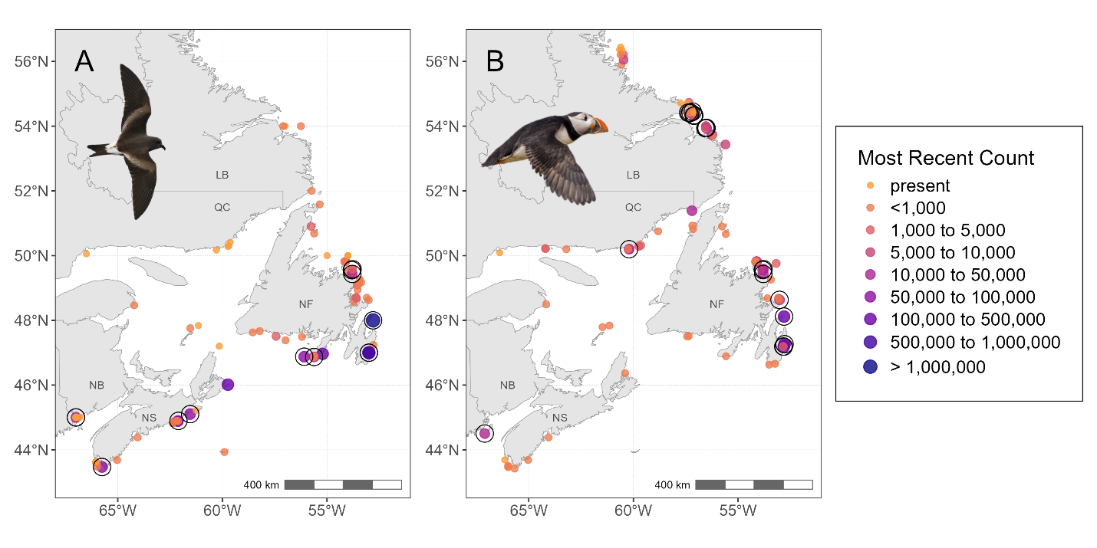

**Figure 1.** Colony locations and colony size estimates from the most recent reported count of mature individuals for (A) Leach’s storm-petrel and (B) Atlantic puffin. Colonies with “at least one pair” reported are labeled as “present”. Colonies contributing at least two years of survey count data to trend models (see Figures 2 and 3) are surrounded by black open circles. Abbreviations indicate province except insular Newfoundland (NF) and Labrador (LB).

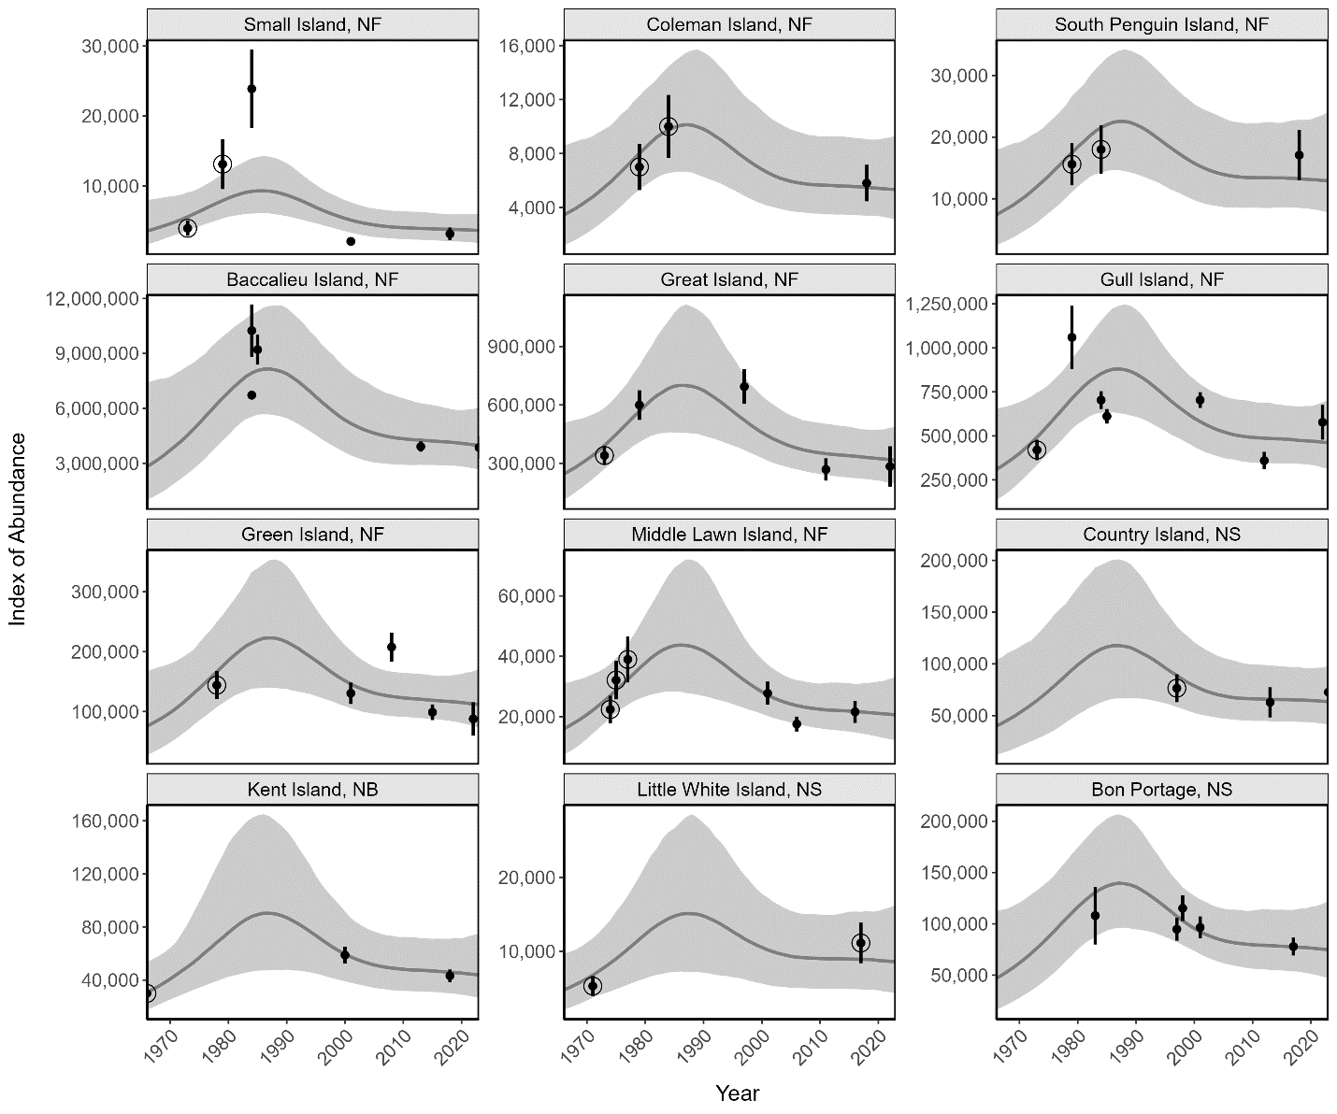

**Figure 2.** Colony-level trajectories for Leach’s storm-petrel derived from the Bayesian hierarchical GAMM over the period 1966-2023 (ordered by latitude, 12 colony locations shown in Figure 1A). Raw survey counts are shown as black points with standard error estimated by the GAMM (counts without raw estimated SE are indicated by open circles). The solid gray line and ribbons depict colony-level trajectories as posterior median and 95% confidence interval.

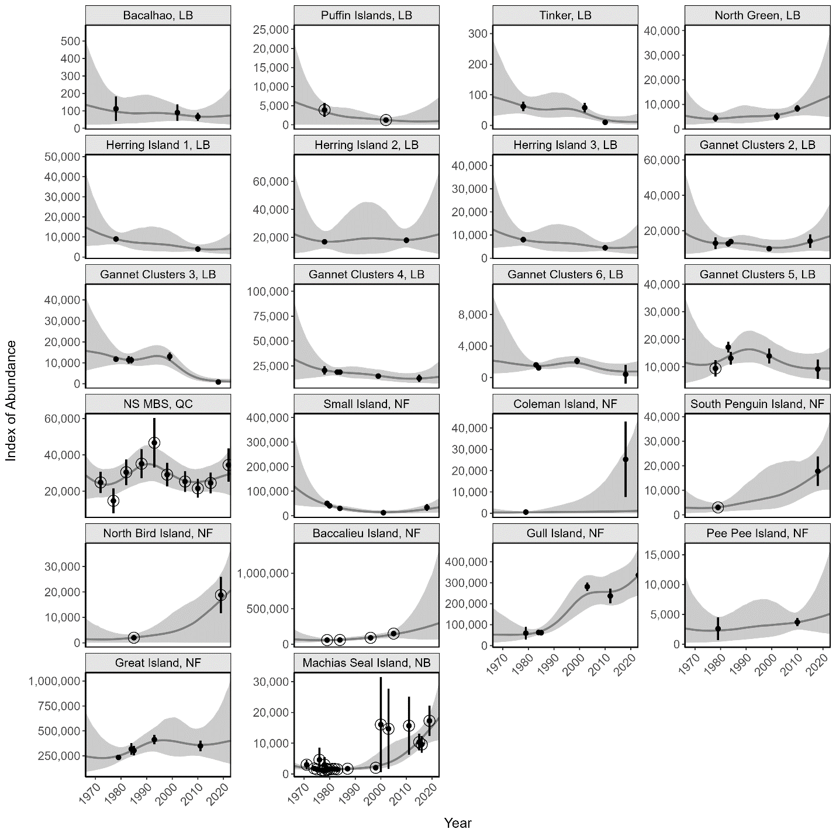

**Figure 3.** Colony-level trajectories for Atlantic puffin derived from the Bayesian hierarchical GAMM over the period 1965-2023 (ordered by latitude, 22 colony locations shown in Figure 1B, note the colony indicated as NS MBS, QC (North Shore Migratory Bird Sanctuaries in Quebec) is the summed abundance across six colonies in this region). Raw survey counts are shown as black points with standard error estimated by the GAMM (counts without raw estimated SE are indicated by open circles). The solid gray line and ribbons depict colony-level trajectories as posterior median and 95% confidence interval.

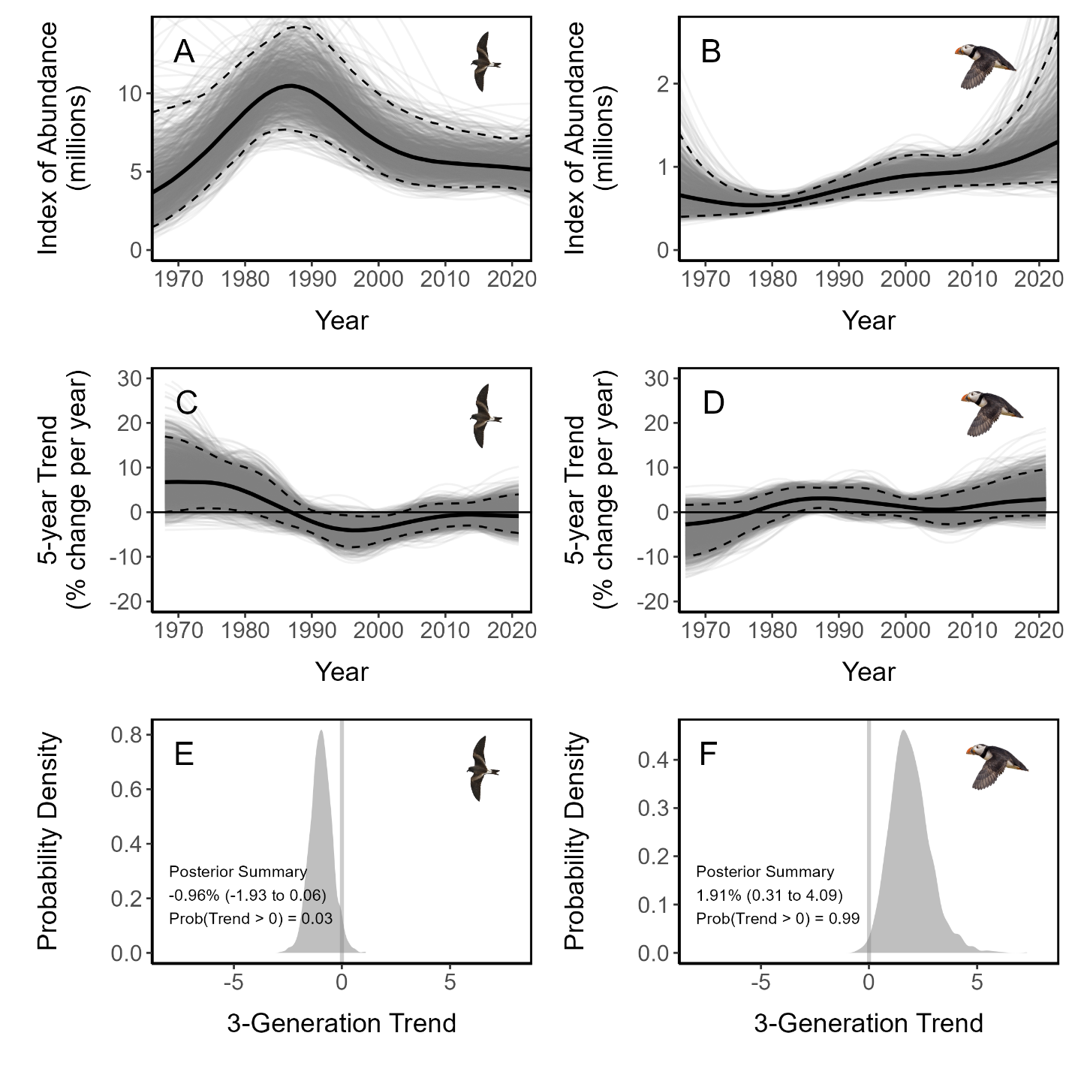**Figure 4.** Regional trajectories (A & B), regional trends over sliding 5-year windows (C & D), and 3-generation trend estimates (E & F) for Leach’s storm-petrel (left panels) and Atlantic puffin (right panels). For regional trajectories and sliding 5-year trends (A-D), thin gray lines depict different samples from the Bayesian posterior to illustrate the diversity of potential trajectories the regional populations may have experienced. Thick black lines illustrate the posterior median, and dashed lines indicate 95% credible interval (i.e., 95% of thin gray lines are within the credible interval). For 3-generation trends, Bayesian posteriors are presented as density plots with a vertical gray line at 0 indicating population stability. Posterior summaries describe the median estimate of the 3-generation trend with 95% credible intervals in parentheses.

# APPENDICES

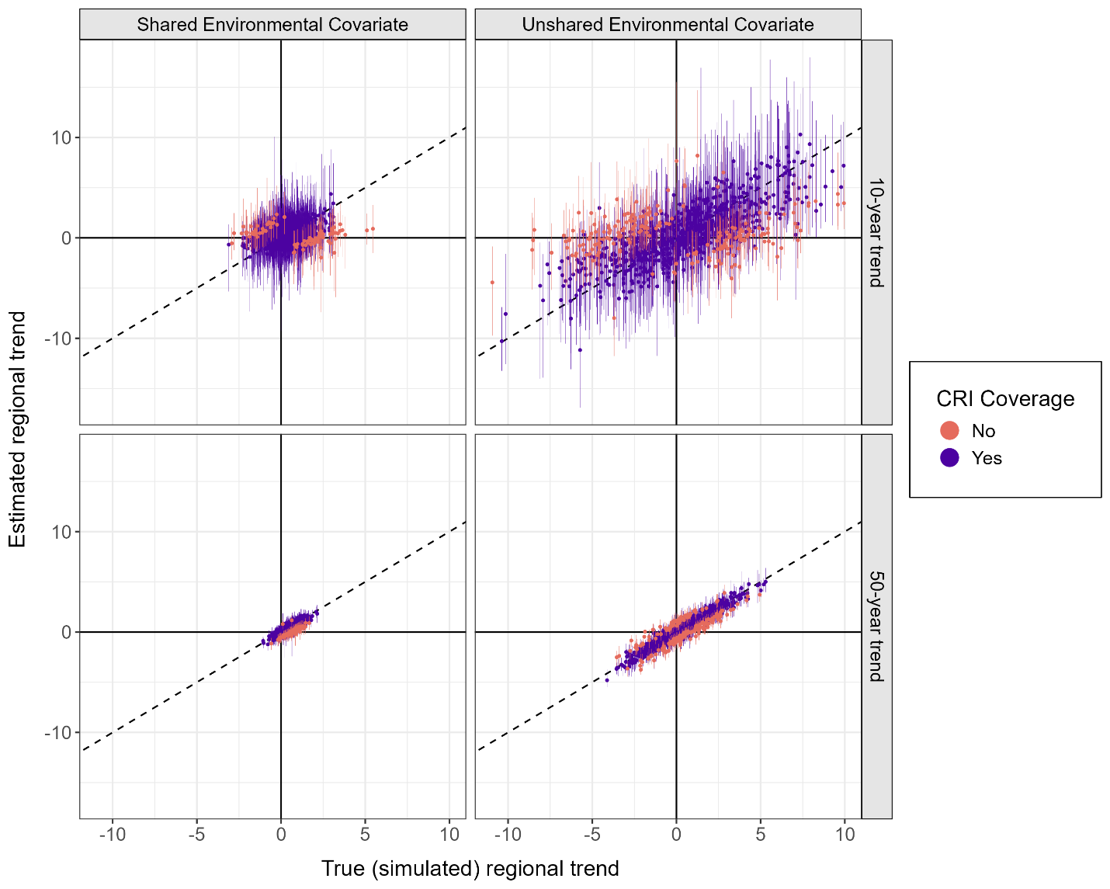

**Figure A1.** Results of 1,000 simulated hypothetical scenarios of population change derived using a Bayesian GAMM approach based on 2-6 imprecise surveys from 15 colonies over a 50-year time period. Credible interval (CRI) coverage indicates whether the 95% credible interval of the estimated regional trend (vertical error bars) captured the “true” simulated regional trend for the most recent 10-year interval (top panels) or a full 50-year interval (bottom panels), under simulations where population dynamics at each colony were affected by an autocorrelated shared environmental covariate imposing correlations among the colony trajectories (left panels) or an unshared environmental covariate (right panels).

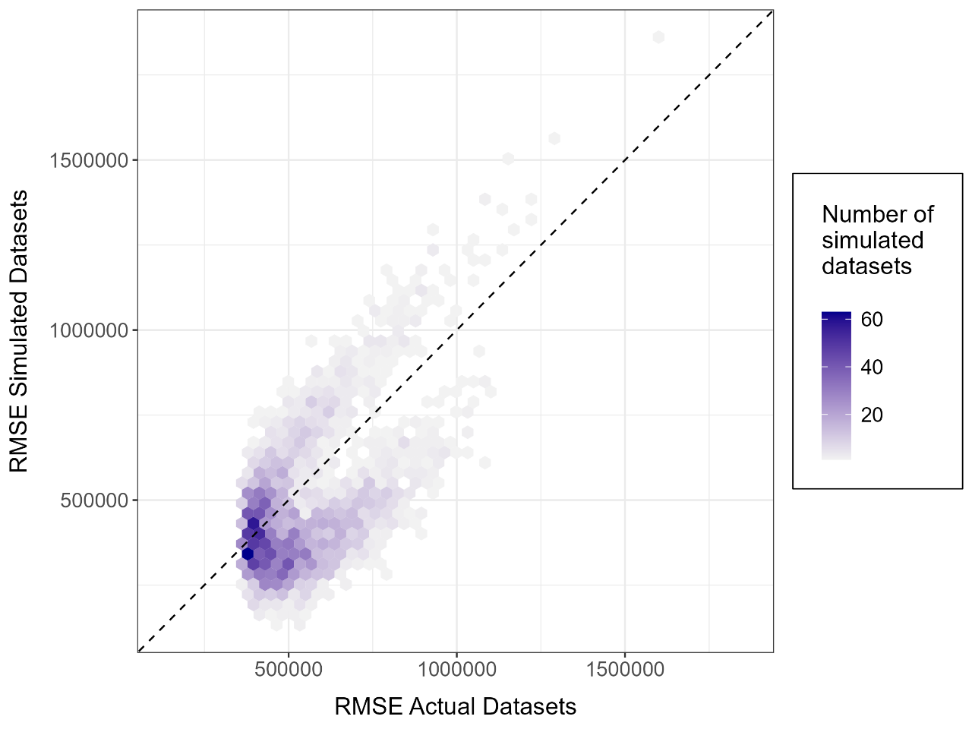

**Figure A2**. Posterior predictive check for petrel GAMM.

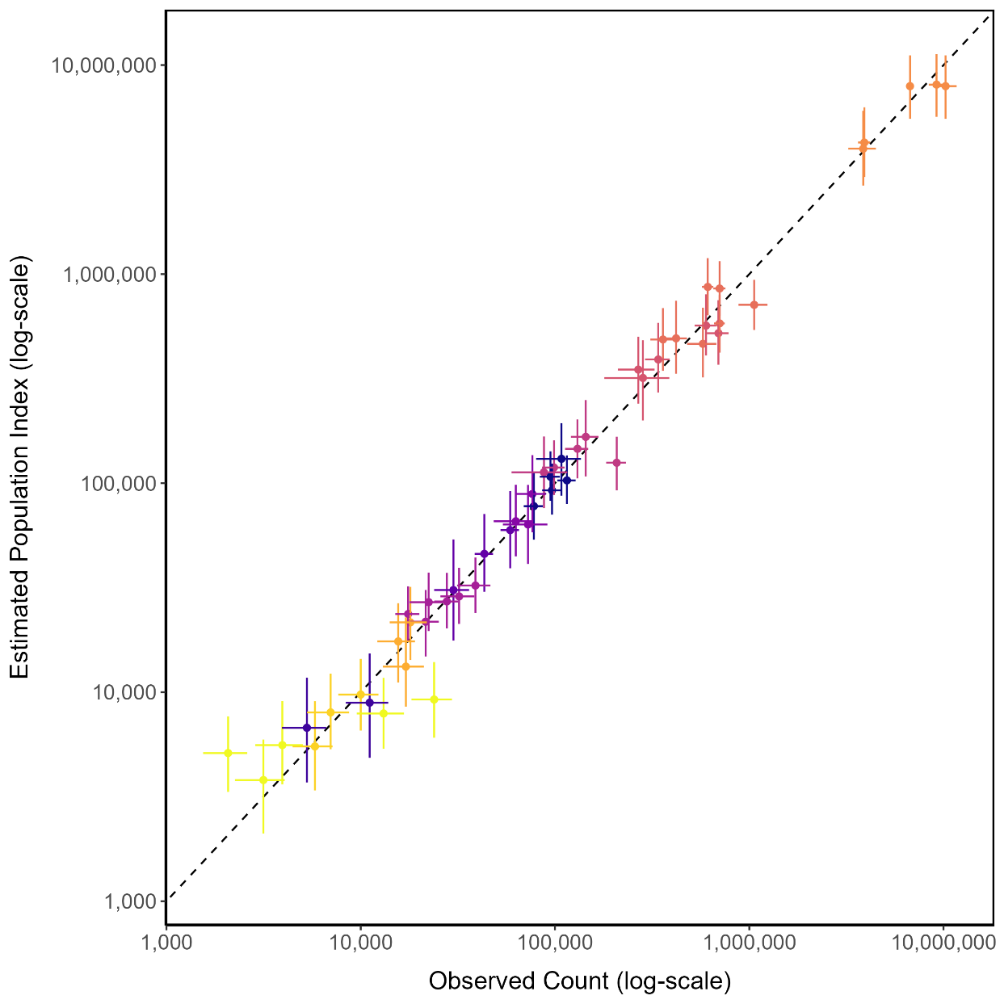

**Figure A3**. Observed vs. Predicted counts for storm-petrels. Colonies uniquely colored.

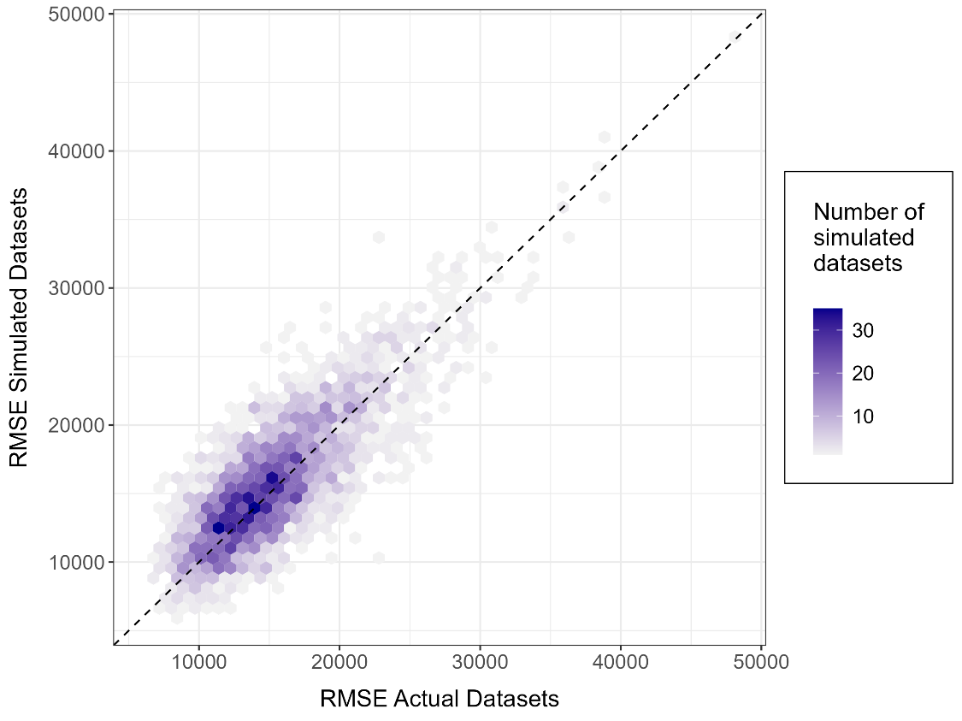

**Figure A4**. Posterior predictive check for puffin GAMM.

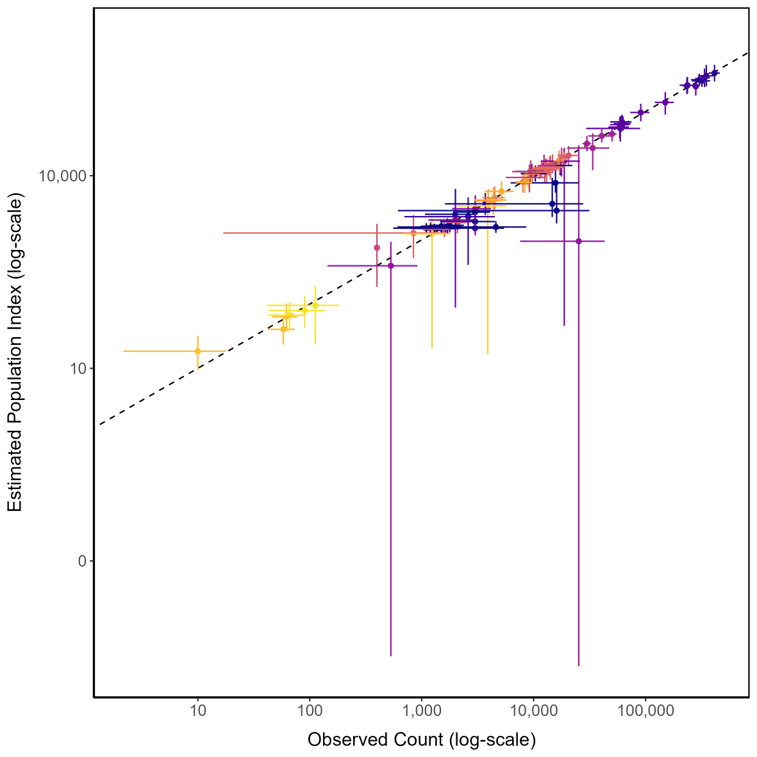

**Figure A5**. Observed vs. predicted values for puffins. Colonies uniquely colored.